University Of Engineering and Technology, Lahore
Computer Engineering Department

Course Name: Programming Fundamentals | Course Code: CMPE-112L
Assignment Type: Lab Report | Dated:
Semester: 1st | Session: 2026 Spring
Lab/Project/Assignment #: 6 | CLOs to be covered: CLO
Lab Title: List, Tuple, Dictionary | Teacher Name: Hafiz Muhammad Mubashar
Lab Evaluation:

CLO1 | Apply appropriate programming techniques to create executable programs to solve well defined problems
 | Level1 | Level2 | Level3 | Level4 | Level5 | Level6
(5)
Total |  |  |  |  |  | /5
Rubrics for Current Lab Evaluation
Scale | Marks | Level | Rubric
Excellent | 5 | L1 | Submitted all lab tasks, BONUS task, have good understanding.
Very Good | 4 | L2 | Submitted the lab tasks but have good understanding
Good | 3 | L3 | Submitted the lab tasks but have weak understanding.
Basic | 2 | L4 | Submitted the lab tasks but have no understanding.
Barely Acceptable | 1 | L5 | Submitted only one lab task.
Not Acceptable | 0 | L6 | Did not attempt
LAB No 1
Lab Goals/Objectives:
• Understand lists, tuples, and dictionaries.
• Learn to store and access data using these data structures.
Equipment Required:
• Computer/Laptop
• Python 3.x
• IDE (IDLE, VS Code, or PyCharm)

Theory:

Lists, tuples, and dictionaries are built-in Python data structures. A list is an ordered and mutable collection of items. A tuple is an ordered but immutable collection. A dictionary stores data as key-value pairs, allowing fast and efficient data retrieval.

Lab Work:

List:

Task 1:
l=[1,"ali",45]
l.append(5)
print(l)

Result:
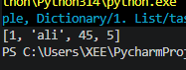

Task 2

fruits = ["apple", "banana", "mango"]
print(fruits)

Result:
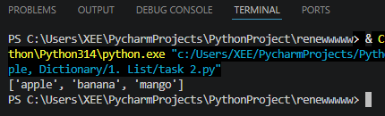

Task 3:
fruits = ["apple", "banana", "mango"]
fruits.remove("banana")
print(fruits)

Result:
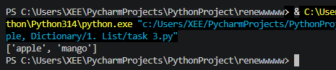

Task 4:
numbers = [10, 20, 30, 40, 50]
print(max(numbers))
print(min(numbers))
print(sum(numbers))

Result:
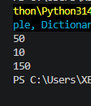

Tuples:

Task 1:
fruits = ("apple", "banana", "mango")
print(fruits)

Result:
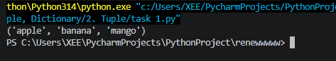

Task 2:
my_tuple = (1, 2, 3)
print(type(my_tuple))

Result:
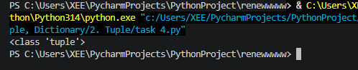

Dictionary:

Task 1:
a={"apple":"saeb","mango":"aam","grapes":'angoor'}
print(a["apple"])

Result:
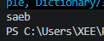

Task 2:
a={"apple":"saeb","mango":"aam","grapes":'angoor'}
print(a["apple"])
print(a["mango"])
a ["dates"]="khajoor"
print(a)

Result:
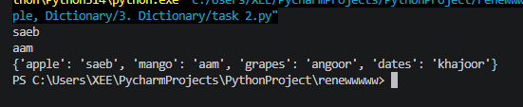
Task 3:
student = {"name": "Ali", "age": 20}
student["city"] = "Lahore"
print(student)

Result:
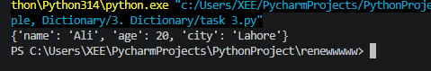
Conclusions:

In this lab, we learned how to use lists, tuples, and dictionaries to store and manage data in Python. We also practiced performing basic operations on these data structures and understood their different uses.

